TILBUDSBREV

Equinor ASA - Sleipner

TECHNICAL SPECIFICATION

Product | 16” RVTB 10K WATER & GAS |  | 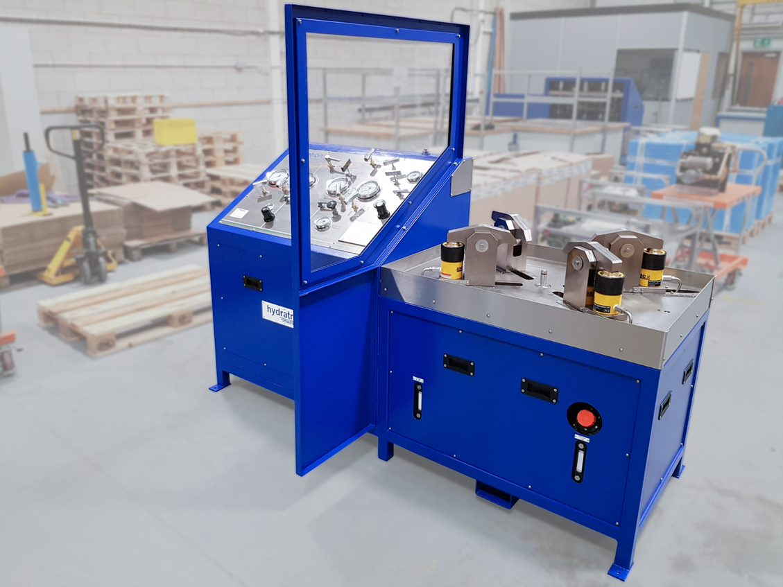
Date | 06/07/2022
Specification Ref | TS-22-25322
Revision | 00 | *Designed in accordance with above –picture for representation purposes only  - Original issue

Equinor ASA

07.07.2022

Vedrørende forespørsel – Safety Relief Valve Test Bench

Vi takker for deres forespørsel og har gleden av å tilby som beskrevet i dette tilbudsbrev.

Scope
Safety Relief Valve Test Bench with hydraulic clamping system suitable for testing ½” to 16” flanged and ½” to 2” screwed relief valves at pressures up to 700 Bar (10,000PSI) using water or bottled Air/Nitrogen as the test medium
Technical Description - TS-22-25322

The Test System would comprise the following;

Flange Adaptors

A range of 3 adaptor plates is included to enable the operator to clamp and seal any of the above valves to the test rig securely.
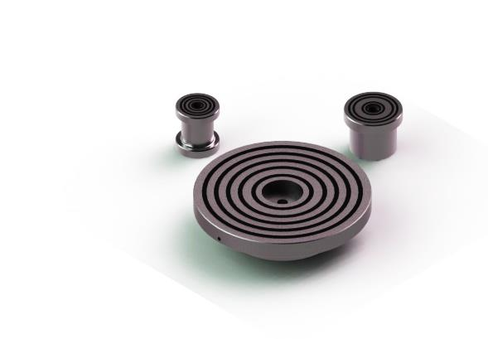

Due to the quantity and hence the potential high cost, prices for adaptor plates to suit RTJ flanged valves are given separately. Customer to provide more details on RTJ flanges.

The Test Bench comprises of the following equipment:

Common Air Supply

Comprising of:
- ½” BSP(F) Self Venting Ball Valve
- Filter
- Lubricator

Hydraulic Test System

Test bench incorporates all the necessary equipment and controls to enable the operator to test safety relief valves using hydraulic oil or water as the test medium. System includes:
- AZ-1 series air operated hydraulic pump.
- Hydraulic pump air controls comprising of a pressure regulating valve, 50 mm (2”) diameter 0-11 Bar (160 PSI) pressure gauge and pump start/stop valve.
- Second pressure regulating valve pre-set to limit the output pressure of the pump to that of the test bench.
- 45 litre (10 gallon) capacity oil/water reservoir fitted with a sight glass, filler cap, drain valve, suction strainer and stop valve.
- Two 100 mm (4”) diameter dual scale pressure gauges, ± 1% full scale accuracy.
- 10 litre (2.2 gallon) capacity accumulator.
- Accumulator isolation valve.
- Pressure release valve.
- Safety relief valve.
- Flow Control Valve

Other Controls / Instrumentation

- Pressure release valve.
- Test gauge (see optional extras) bulkhead fitting threaded ½” BSP female.

Nitrogen / Air Test System
Test bench incorporates all the necessary equipment and controls to enable the operator to test safety relief valves using nitrogen or air as the test medium.
This equipment comprises of:
- Inlet gas bulkhead connector threaded ¼” NPT female.
- Inlet gas stop valve.
- Inlet gas filter.
- 180 BAR gas reducing regulator
- 100 mm (4”) diameter dual scale gas inlet pressure gauge. Full safety pattern, ± 1% full scale accuracy.
- Two 100 mm (4”) diameter dual scale gas pressure gauges. Full safety pattern, ± 1% full scale accuracy.
- Pressure release valve.
- Safety relief valve
- Metering Valve

Other Controls / Instrumentation

- High pressure fine metering valve.
- Pressure release valve.
- Test gauge (see optional extras) bulkhead fitting threaded ½” BSP female.

Hydraulic Clamping System
The valve test bench incorporates a hydraulic clamping system comprising finger type clamps. These are capable of a combined clamping force of 100 tonnes and are fully adjustable to cater for the entire valve sizes stated. To adjust the clamps, simply slide each one in or out manually by hand to suit the size of valve being tested. The clamp control valve is then operated in order to hydraulically clamp the valve in place prior to allowing test pressure to be introduced. A range of adaptor plates is included, each having a series of ‘O’ ring grooves machined into their faces. This allows the operator to fit a corresponding ‘O’ ring into the groove in order to provide a seal on the valve face without the need for gaskets.

The hydraulic clamps are powered by a circuit consisting of the following equipment:
- An AZ-1 series air operated hydraulic pump.
- Hydraulic pump air controls comprising of a pressure regulating valve, 50 mm (2”) diameter 0-11 Bar (160 PSI) pressure gauge and pump start/stop valve.
- Second pressure regulating valve pre-set to limit the output pressure to the maximum hydraulic clamping system pressure.
- 9 litre (2 gallon) capacity oil reservoir fitted with a sight glass, filler cap, drain valve, suction strainer and stop valve.
- Pressure release valve.

Interlock System
The test circuit is interlocked with the auto clamp circuit to prevent test pressure from being introduced into the valve under test until the valve is securely clamped in place. Similarly, the auto clamp circuit is interlocked with the test circuit preventing the clamps from being released until the test pressure has been released.

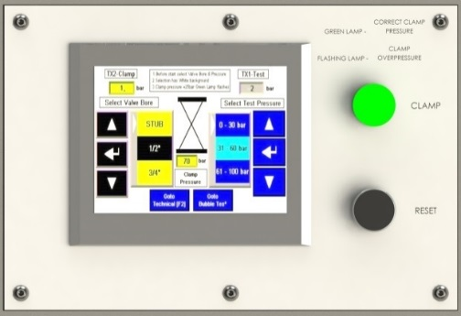

General
- All high-pressure interconnecting pipework and fittings are manufactured from stainless steel material whilst the low pressure and pneumatic pipework and fittings are manufactured from brass, copper and nylon.
- All instrumentation and controls are mounted on a stainless steel engraved and colour coded control panel situated at a convenient working height for easy operation.
- The above equipment is assembled within a robust mild steel cabinet having removable panels at the front and rear for ease of maintenance.
- Safety Shield manufactured from safety glass. Protects the operator and permits viewing while valves are undergoing tests.
- The cabinet is provided with forklift truck pockets to facilitate easy loading/unloading.
- The cabinet and clamp supporting framework are finished with a polyester epoxy coated ultramarine blue (RAL5002) powder coating.
- The Unit is controlled by means of a PLC and panel mounted touchscreen HMI providing control monitoring and safety/interlock functionality.

Documentation
Our quoted price includes for the supply of one set of the following documentation:
- EU Declaration of Conformity covering the unit as a whole.
- Hydratron Test Certificate.
- Pressure gauge Certificate of Conformity (not point to point)
- Certificates of Conformity covering bought out items – where issued free of charge.
- Hydratron standard Installation, Operating and Maintenance Instructions.
- Circuit Diagram.
- General Arrangement drawing
- Parts List.

DATA ACQUISITION SYSTEM

The Digital Pressure Transducer possesses the ability to measure, analyse and record pressure directly onto your PC or laptop without the need for costly I/O interface boards.

• Silicon on sapphire sensor technology
• USB 1.1 and USB 2.0 full speed compatible
• Auto detection and configuration
• Hot pluggable and solely powered by USB bus
• Windows interface software supplied
• Extremely high 21 bit resolution
• Excellent stability and repeatability
• Includes built in temperature monitoring
• IP68 USB cable included
• Ranges from 500 mbar to 1,500 bar
• Measure up to 8 pressure inputs simultaneously.

ELECTRONIC BUBBLE COUNTER

Used when testing valves using nitrogen or air as the test medium.

It enables the operator to monitor and record the number of bubbles passing the valve seat without continual visual observation.

The device meets the criteria outlined in API Spec 527.

INTERLOCKED TEST COMPARTMENT

Clamping system housed within a fully interlocked test compartment having an open top along with hinged and latched access door at the front to facilitate loading/unloading by overhead hoist. The rear wall is fully panelled in mild steel, and the side walls along with the doors are fitted with Makrolon or equivalent safety glass viewing windows.
